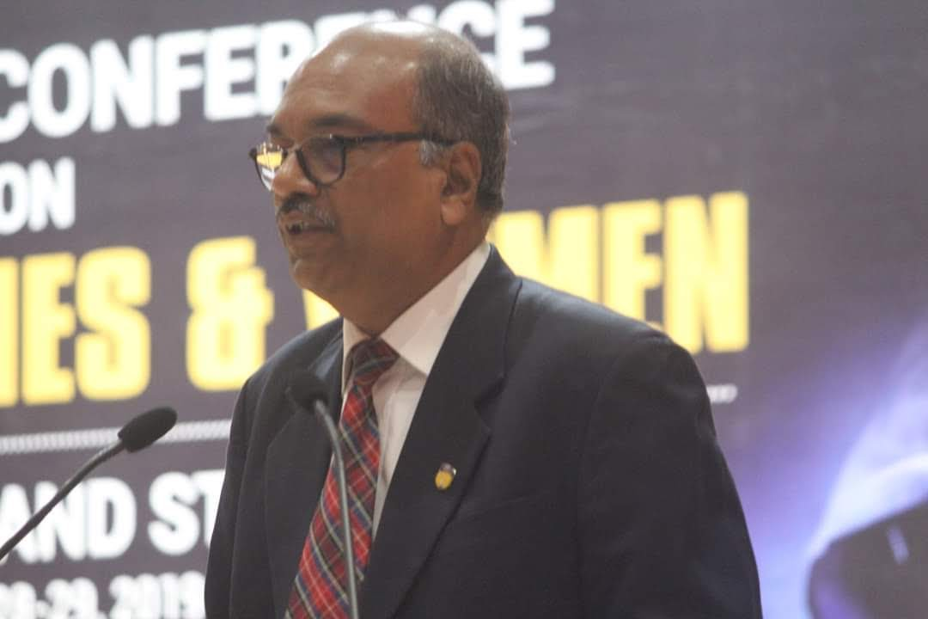

**Professor (Dr.) Surajit C Mukhopadhyay**

**Brief profile**

Professor (Dr.) Surajit C Mukhopadhyay is currently a Professor and Dean of Humanities and Social Sciences, The Assam Royal Global University. He has held senior positions in several universities and research institutions in the faculty as well as in administration and has been a member of the apex social science body in India – the Indian Council for Social Science Research (ICSSR). A consultant for several national and international bodies including the government of Switzerland and the Netherlands, he has been actively engaged in field research while serving as a Fellow at the Centre for Studies in the Social Sciences, Calcutta, and has supervised Ph.D. dissertations as well as projects of international interns of UNICEF.

Professor Mukhopadhyay was trained at St. Xavier's College, Calcutta, from where he obtained his undergraduate degree. He did his Master’s and M. Phil at JNU, New Delhi, and was awarded a Ph.D. by Leicester University in the UK, where he was a Commonwealth Staff Scholar. Professor Mukhopadhyay also studied at the University of Oslo in Norway on a NORAD scholarship and has two post-doctoral awards from Paris and New York. He specializes in political Sociology and has published extensively in national and international journals as well contributed chapters in books on Sociology and Political Sociology. Currently, he is engaged in a book project that he is co-editing with a colleague to be published by Routledge, London.

Founding faculty of the Department of Sociology at the University of Burdwan, West Bengal, Professor Mukhopadhyay has presented papers and lectures in the UK, Cyprus, Hong Kong, Nepal, Russian Federation, France, Costa Rica, South Africa, and Indonesia apart from universities and research institutions in India.